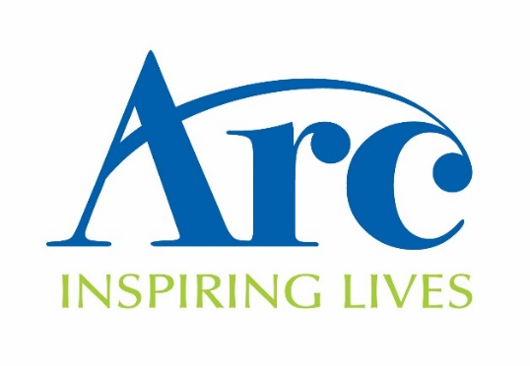
Arc Sponsorship Form Participants Name: _____________________________
I have chosen to take part in the Big Sleep Out on behalf of Arc. Please show your support by sponsoring me.
Make your sponsorship go further! Using Gift Aid means that for every £1 you give, we can get an extra 25p from the government, helping your sponsorship to go further at no extra cost to you! In order for us to claim gift aid, we must have a full name, house number/name and postcode and a ticked box! Please help us to claim an extra 25p per £1 by filling out your details in full.
By ticking to claim Gift Aid, you are stating that you are a UK tax payer and would like Arc to treat all donations that you have made in the past five years and any future donations from today, until said otherwise, as Gift Aid donations. In order to claim Gift Aid you must have paid an amount of income tax/and or capital gains tax equal to the tax reclaimed.

Sponsor Full Name | Address (please fill in at least your house number/name) | Postcode | Gift Aid (please tick if you are a UK Tax Payer) | Donation Amount (£)
Sponsor Full Name | Address (please fill in at least your house number/name) | Postcode | Gift Aid (please tick if you are a UK Tax Payer) | Donation Amount (£)

